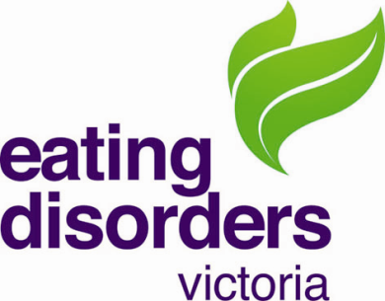
Director – Board member

About the role

The EDV Board comprises up to 9 members with substantial skills and expertise, drawn from the corporate, private, public,health and community sectors. The Board members work in a voluntary capacity to provide strategic oversight and governance in line with EDV’s mission.
We have a vacancy on the board and EDV is seeking a director who ideally has worked in eating disorders service delivery, preferably as a senior clinician with leadership responsibilities.
Applicants should be able to demonstrate effective communication skills and strong relationship building capabilities. Knowledge of the community and/or health sector is a prerequisite. The board member will be expected to attend all board meetings, participate in the clinical governance subcommittee, and support the strategic plan of the organisation.
The time commitment will be approximately 8 hours per month.
All board members are required to be paid members of EDV.
Selection Criteria
Our ideal candidate would be an experienced eating disorder clinician who is currently or recently worked in a leadership role. In addition, skills and experience in at least one other of the following is preferred:
- Governance experience as a board member
- Government relations, public policy, service development
- Health promotion, community education or health education
- Marketing or public relations
- Fundraising or sponsorship initiatives
- Lived experience of an eating disorder as someone who has recovered or as a carer/family member, partner of someone affected by an eating disorder

Closing date is Thursday 20th May 2021

About the Organisation

Eating Disorders Victoria (EDV) is the leading community organisation helping Victorians understand and recover from eating disorders. A trusted source of support since 1983, EDV delivers a broad range of free and low-cost community services that respond across the breadth of the eating disorder experience – from discovery to recovery.
Our services exist to:
- Guide Victorians to the services needed for timely, evidence-based care.
- Equip Victorians with the skills developed by those with lived experience to help themselves.
- Provide Victorians with innovative community programs that aren’t available elsewhere.
- Be a voice that guides Victorian stakeholders (health professionals, community leaders, decision makers) to the knowledge required to strengthen the broader system of care.
Our services are for individuals affected by eating disorders, as well as the families, communities and professionals that support them.
EDV’s work is proudly informed by lived-experience, as well as the expertise of health professionals and evidence-based approaches. We are a strong voice for lived experience and actively advocate for our community at local and national level.
More information about EDV can be found at www.eatingdisorders.org.au
How to Apply
For information about EDV, please contact Belinda Caldwell (CEO) or Kelly Edwards (insert title). Belinda can be contacted at belinda.caldwell@eatingdisorders.org.au on 0433801045. Kelly can be contacted on x and y (insert details)
For information about the board position, please contact Christine Fyffe (Board chair) on 0417144429 or at christinefyffe@bigpond.com
Written applications that address your suitability for the role and include a current CV will be accepted by email at board@eatingdisorders.org.au

