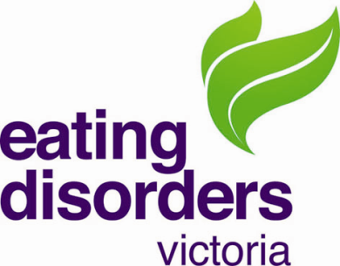
Director – Board member

About the role

The EDV Board of Directors comprises up to 9 members with substantial skills and expertise, drawn from the corporate, private, public and community sectors. The Board members work in a voluntary capacity to provide strategic oversight and governance in line with EDV’s mission.
We have a vacancy on the board and EDV is now seeking a director with experience in government relations and advocacy. We are looking for someone with existing networks in both State and Federal Government in the areas of health.
Applicants should be able to demonstrate effective communication skills and strong relationship building capabilities. Knowledge of the community and/or health sector is an advantage but not a prerequisite.
The board member will be expected to attend all board meetings, join a subcommittee and support the strategic plan of the organisation.
We strongly encourage applicants from diverse backgrounds and previous board experience is not essential.
The time commitment will be in the vicinity of 6-8 hours/mth.
All board members are required to be paid members of EDV.

Selection Criteria
Our ideal candidate would have demonstrated experience in government relations and advocacy. In addition, skills/experience in at least one other of the following is preferred:
- Governance experience as a board member, or CEO experience
- Health promotion, community education or health education
- Marketing or public relations
- Government relations, public policy
- Fundraising or sponsorship initiatives
- Lived experience of an eating disorder as someone who has recovered or as a carer/family member, partner or friend of someone affected by an eating disorder
Closing date is Thursday 20th May 2021

About the Organisation

Eating Disorders Victoria (EDV) is the leading community organisation helping Victorians understand and recover from eating disorders. A trusted source of support since 1983, EDV delivers a broad range of free and low-cost community services that respond across the breadth of the eating disorder experience – from discovery to recovery.
Our services exist to:
- Guide Victorians to the services needed for timely, evidence-based care.
- Equip Victorians with the skills developed by those with lived experience to help themselves.
- Provide Victorians with innovative community programs that aren’t available elsewhere.
- Be a voice that guides Victorian stakeholders (health professionals, community leaders, decision makers) to the knowledge required to strengthen the broader system of care.
Our services are for individuals affected by eating disorders, as well as the families, communities and professionals that support them.
EDV’s work is proudly informed by lived-experience as well as the expertise of health professionals adopting evidence-based approaches. We are a strong voice for lived experience and actively advocate for our community at local and national level.
More information about EDV can be found at www.eatingdisorders.org.au

How to Apply
For information about EDV, please contact Belinda Caldwell (CEO). Belinda can be contacted at belinda.caldwell@eatingdisorders.org.au on 0433801045.
For information about the board position, please contact Christine Fyffe (Board chair) on 0417144429 or at christinefyffe@bigpond.com
Written applications that address your suitability for the role and include a current CV will be accepted by email at board@eatingdisorders.org.au

